Record No: 0665
SIR JOHN RALPH STARKEY (Sir Ralph)
of Norwood Park, Southwell, Nottinghamshire.

Father of Lucy Margaret Starkey(0664) ‘Greta’ by his wife, Emily, daughter of Sir Charles Seely.

Birth: 1 Mar 1859
Marriage: 31 Oct 1888 to Emily, dau of Sir Charles Seely
Death: 13 Nov 1940

Source: Somerville Index

Notes: 1 son, 7 dau

Hilda M, born c1891
Phyllis J, 1893
Alice B, B 1894
Florence E, 1897
Helen F, 1898
William R, 1900
Sylvia A, 1901-1902
Margaret Lucy, Sep-Dec 1903

Additional information by D R G GILMOUR

Unionist MP for Newark, Nottinghamshire 1906-1922
Dep. Lt. Nottinghamshire 1906-1907
Cr 1st Baronet Starkey of Norwood Park in the King’s Birthday and Jubilee Honours 1935
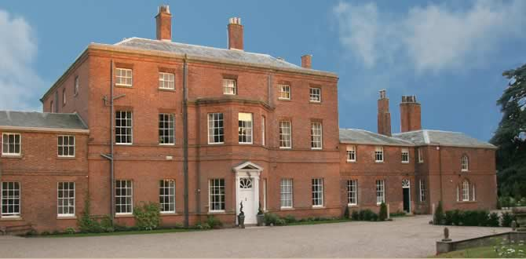

Norwood Park
For some 800 years, Norwood Park was owned by the Archbishop of York as part of the Manor of Southwell which was given to him in 956 by the Saxon King. In early medieval times a Deer Park was created in a tract of woodland pasture, notable for its fine specimen oak trees and fish ponds, by enclosing it within an earthwork that still exists.
Edward Cludd, the estate manager at the time of the Civil War used his friendship with Oliver Cromwell to acquire the Park. He built the first ‘pretty little brick house’. Too small for John Sutton who later took over the lease of the Park, it was replaced by the present handsome Georgian mansion in the 1760’s. At the same time, the Park was landscaped with the addition of the Temple, two more fishponds and the Lime Avenue.
Since 1881, when Lewis Starkey moved his family from Yorkshire, Norwood has been home to five generations. John Ralph Starkey planted the first Bramley orchard in 1910 when MP for Newark. His son William and grandson John have kept the fruit growing tradition alive which also includes a substantial strawberry enterprise.
http://norwoodpark.co.uk/norwood_history.html

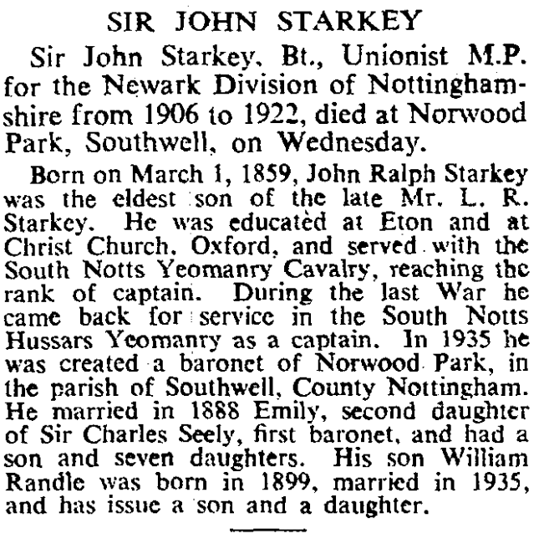
The Times, Friday 15 Nov 1940

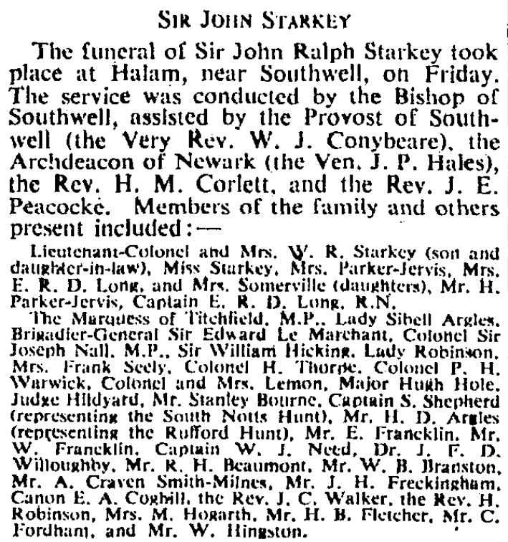
The Times, 18 Nov 1940

Captain Sir John Ralph Starkey, 1st Bt.¹
M, #62226, b. 1 March 1859, d. 13 November 1940
Last Edited=10 Jul 2011
Captain Sir John Ralph Starkey, 1st Bt. was born on 1 March 1859. He married Emily Seely, daughter of Sir Charles Seely, 1st Bt. and Emily Evans, on 31 October 1888.¹ He died on 13 November 1940 at age 81.
Captain Sir John Ralph Starkey, 1st Bt. gained the title of 1st Baronet Starkey.

Child of Captain Sir John Ralph Starkey, 1st Bt. and Emily Seely
- Hilda Margaret Starkey+² d. 1979

Citations
- [S8] Charles Mosley, editor, Burke's Peerage and Baronetage, 106th edition, 2 volumes (Crans, Switzerland: Burke's Peerage (Genealogical Books) Ltd, 1999), volume 2, page 2573. Hereinafter cited as Burke's Peerage and Baronetage, 106th edition.
- [S37] Charles Mosley, editor, Burke's Peerage, Baronetage & Knightage, 107th edition, 3 volumes (Wilmington, Delaware, U.S.A.: Burke's Peerage (Genealogical Books) Ltd, 2003), volume 2, page 2458. Hereinafter cited as Burke's Peerage and Baronetage, 107th edition.
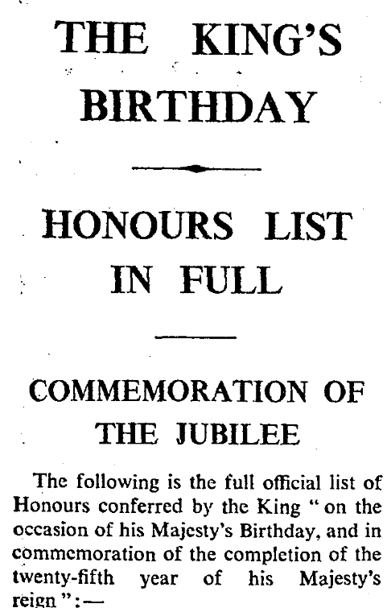

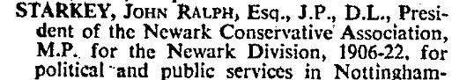
The Times, 3 June 1935

